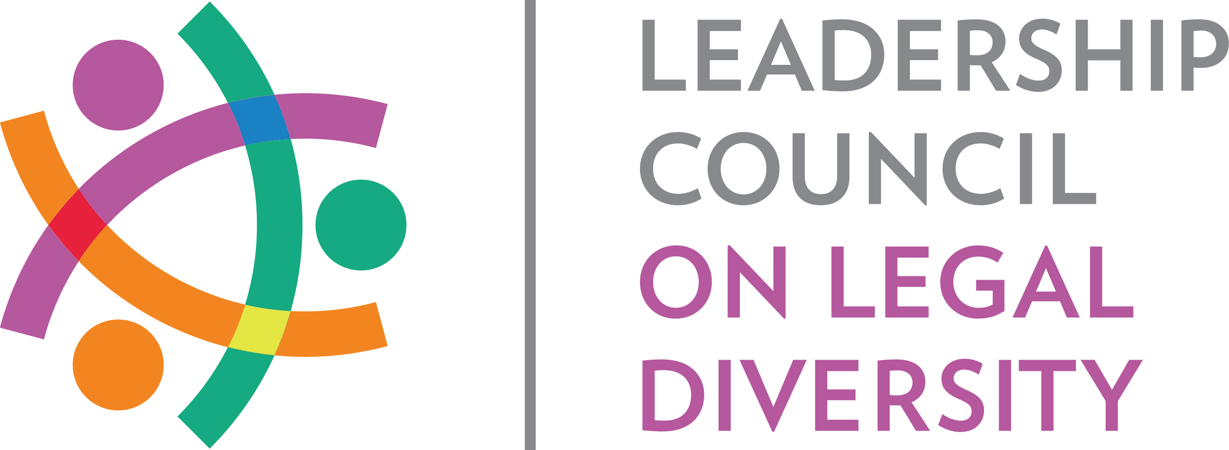

**LCLD Success in Law School Mentoring Program**

**Letter to Law Schools, Past Participants**

**[Date]**

**[Greeting],**

The Leadership Council on Legal Diversity (LCLD) Success in Law School Mentoring Program has experienced tremendous success since inception, so it is with great excitement that I announce the launch of the program for the 2022-2023 school year. I am pleased that so many students from **[*Law School Name*]** have participated in this unique mentoring opportunity in the past and look forward to your continued participation.

If you plan to participate again this year,the available program launch dates are September 15, 2022, October 3, 2022, or October 17, 2022. Once students register and are matched, they will receive ongoing mentorship from lawyers practicing in the country’s finest companies and law firms.

I will follow up with you in the next few days to identify a launch date. Once a launch date has been selected, simply forward the attached letter to your diverse 1L students. If you have additional questions, please feel free to contact me or Nancy Richardson, LCLD Program Manager ([nrichardson@lcldnet.com](mailto:nrichardson@lcldnet.com)).

I look forward to working with you again this fall to achieve a stronger, more diverse legal profession!

Sincerely,

**[Name]**

**LCLD City Lead for [City Name]**

**[Contact Information]**

*Internal Note to City Leads: The “Letter to Law Students” is the “attached letter” referenced in the third paragraph of this template.*