**41**

**1**

**I**

**' b**



**—**

What truly sets Kelley Drye apart, however, are the people who work here. We strive to ensure our summer associates are able to make lasting connections over the course of the summer program, both inside and outside the office.

**To Apply:**

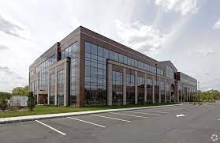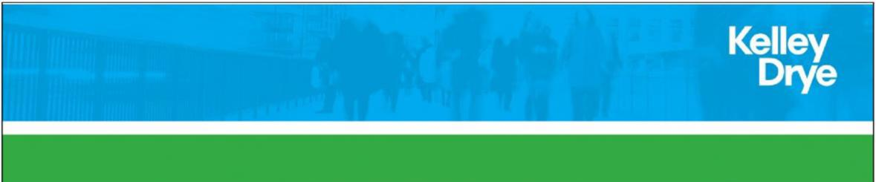

If you are interested in applying for the 1L summer associate position in New Jersey, please submit your cover letter, resume, transcripts (undergraduate, law and graduate, if applicable) and diversity statement [here.](https://kelleydryecareers.viglobalcloud.com/viRecruitSelfApply/ReDefault.aspx?FilterREID=2&FilterJobCategoryID=1&FilterJobID=68) Please indicate in your application that you are applying for the New Jersey office. The salary range displayed is specifically for those potential hires who will work or reside in New Jersey if selected for the role.

[www.kelleydrye.com/Summer-Associates.](http://www.kelleydrye.com/Summer-Associates.)

We seek summer associates who are results-oriented and team players. Strong analytic ability, communication skills and top credentials required. The New Jersey office summer associate position is particularly intended for those who plan to work in New Jersey upon graduation. To learn more about Kelley Drye and our summer associate program, please visit

As a summer associate in our New Jersey office, you will have the opportunity to work closely with our attorneys and contribute to their client matters, because we believe there is no better way to discover what makes our firm unique than to be a part of the action. After a summer with us, we are confident that you will appreciate the results we achieve for our clients, the depth of our professionalism and the down-to-earth atmosphere we enjoy at Kelley Drye.

**1L Summer Associate in New Jersey**

Kelley Drye’s New Jersey office has been a center of legal excellence, providing Fortune 500 clients in the state and nationwide with efficient, sophisticated services. In this office, we are particularly regarded for our litigation, real estate, environmental and intellectual property work.

Kelley Drye & Warren’s Parsippany, New Jersey office is looking for one first-year law student to join our 2023 Summer Program as part of the LCLD Scholars Program.