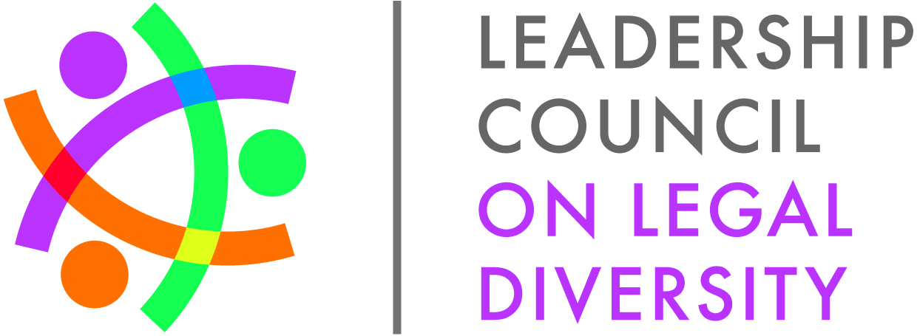**Diversity Professionals Phone Conference**

**January 14, 2015**

**3:00-4:00pm EST**

**Agenda**

**Call In: 877-294-8214**

**Access Code: 5075876**

1. Welcome
2. Program Updates
   1. 2015 Fellows class

* The Fellows welcome packages will be emailed to all Fellows by 1/23/2015.
* Member Tool Kit – will be mailed out in the coming weeks to the Members and we will send a link to diversity professionals and Fellows.
  1. Fellows Alumni
     1. Save the date – Fourth Annual Fellows Alumni Conference

June 11 – 14, 2015 at The Hotel Monteleone in New Orleans. Registration is open and is on the LCLD website: <http://www.lcldnet.org/events/2014/10/fourth-annual-lcld-fellows-alumni-conference/>.

* + - * Planning Committee
* This is the first year we’ve planned the conference through an LCLD Fellows Alumni Committee – and they’ve done a great job building a fantastic conference agenda!
* Sponsorship opportunities are still available
  + - * 1. Reach out to Courtney Nolde at [cnolde@lcldnet.com](mailto:cnolde@lcldnet.com) for more information.
    1. Alumni Executive Council meeting in February
* Strategic planning meeting at Deloitte University on February 10, 2015
* Deloitte University will help capture the growth and mission strategy of the Alumni Committee.
* Rick Palmore will be attending as the LCLD Board of Directors liaison to the Fellows Alumni Executive Council.
  1. 2014 LCLD Success in Law School Mentoring Program
* Matched more than 750 diverse students – decrease from last year’s program, but still excited by the numbers.
* Mentoring Program is targeted to first year law students soon after they start school. For more information, contact Louise Bald at [lbald@lclcdnet.com](mailto:lbald@lclcdnet.com).
* We love to see you in action! Please send photos of mentoring events to Jessica Smith at [jsmith@lcldnet.com](mailto:jsmith@lcldnet.com).
  + 1. City Lead – call for volunteers
       - Columbus, OH
       - Dallas, TX (to partner with an existing CL)
       - Minneapolis, MN (to partner with an existing CL)
       - Bloomington, IL

If you’re interested in a City Lead position, please email Louise Bald at [lbald@lcldnet.com](mailto:lbald@lcldnet.com).

* 1. 2014 1L Scholars Program
     1. Save the date – 2015 Scholars Summit
* 199 Scholars have been registered for the Scholars Summit!
* 1L Scholars Summit is May 28 – 30, 2015 in Dallas, TX
* Welcome packages will be emailed to Scholars in early May.
  + - * 1. Event is before many students will come into the organizations.
        2. **Please be sure to talk to your Scholar about expenses during travel.**

LCLD is providing meals during the conference.

Students may need to pay for cabs/ground transportation.

* Diversity directors will receive a separate program package with more detail on the Summit and program participation in May.
  + 1. Law firm/Corporate partnerships
* We have 17 Law firm/Corporate partnerships – opportunities to partner are still available. Please contact Louise Bald, [lbald@lcldnet.com](mailto:lbald@lcldnet.com) for more information.
  1. Mid-Year CLE featuring Kenji Yoshino – RSVP/Save the Date
* This event is free for all employees of Member organizations, but seating is limited to 100 – so please RSVP early.
* March 26, 2015 in New York and starts at 12:00 – 4:00 (lunch starts at Noon).
* Additional communications will be emailed out in the coming weeks.
* Topic: Building Inclusive Teams: Covering.

1. 2015 Calendar of Events
   1. Diversity calls (Call-In: 877-294-8214; Access Code: 5075876#)

* April 9, 2015 at 3:00 – 4:00pm ET
* July 21, 2015 at 3:00 – 4:00pm ET
* October 14, 2015 at 3:00 – 4:00pm ET
  1. 2015 Learning Experiences:
* February 5-6 in Orlando, FL – Darden Restaurants
* March 24, 2015 in Washington, DC – Department of Transportation
* April 27, 2015 in Washington, DC – Department of Justice
* June 5, 2015 in Seattle, WA – Starbucks Coffee Company
* June 23, 2015 in Minneapolis, MN – Target Corporation
* October 27, 2015 in St. Paul, MN – 3M
* November 5, 2015 in Washington, DC - SEC

Now scheduling Learning Experience for 2016! To schedule your Learning Experience or to learn more, please email Stephanie Uzel, [suzel@lcldnet.com](mailto:suzel@lcldnet.com).

1. Social media – you are invited to hang out with us any time!
   1. Twitter: <https://twitter.com/LCLD_rgrey>; <https://twitter.com/LoriLCLD>
   2. Facebook: <https://www.facebook.com/TheLCLD>
   3. LinkedIn: <https://www.linkedin.com/groups?home=&gid=4198149&trk=my_groups-tile-grp>
2. Questions/Comments/Suggestions