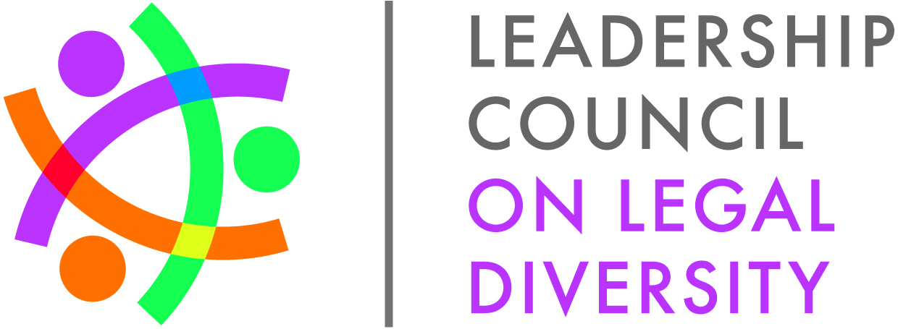**Diversity Director’s Conference Call**

**July 22, 2014**

**3:00-4:00pm EST (New Time)**

**Agenda**

1. Welcome
2. Program Updates
   1. 2014 Fellows

Received great feedback about the fellows. The Fellows class is approximately 180.

* + 1. Leadership Lunches

Since our last call we have had the following lunches

* April 21 Comcast & Stradley Ronon, Philadelphia, PA
* May 20 Target & Faegre Baker Daniels, Minneapolis, MN
* June 23 Microsoft & Perkins Coie, Seattle, WA

How many fellows are on the West Coast? Somewhere between 20 and 35% on the West Coast. A lunch was scheduled for San Francisco that was cancelled and we’re working to reschedule. We do always need volunteers on the West Coast to host lunches and learning experiences.

* + 1. Learning Experiences

Since our last call we have had the following experiences, especially West Coast

* April 24-25 General Mills, Minneapolis, MN
* June 16-17 UnitedHealth Group, Minnetonka, MN

Cam Hoang with General Mills: GM hosted a Learning Experience. Had attendance from across the country and from MN. Had a great session that included professional development and executive presences.

Always looking for learning experiences hosts. They are day-long visits at the corporate member’s organization.

* + 1. September Meeting

The 2014 Fellows will meet September 17-19 in Phoenix, AZ. We have had 16 GC/MPs volunteer to conduct small group breakout sessions with the Fellows. The full agenda is available [online](http://www.lcldnet.org/events/2014/07/2014-fellows-second-meeting/).

* 1. 2015 Fellows – earlier nomination period

We will begin recruiting 2015 Fellows immediately after the 2014 Annual Membership Meeting.

* 1. Fellows Alumni
     1. 2014 Fellows Alumni Conference highlights

We hosted 100 Fellows Alumni at the 2014 Conference

Thank you to our sponsors:

|  |  |  |
| --- | --- | --- |
| **2014 FELLOWS PROGRAM SPONSORSHIPS** | |  |
|  |  |  |
| **Organization** |
| Barnes & Thornburg LLP |
| Carlton Fields Jorden Burt |
| Crowell & Moring LLP |
| Debevoise & Plimpton LLP |
| Greensfelder, Hemker & Gale, P.C. |
| Hanson & Bridgett LLP |
| Hogan Lovells US LLP |
| Holland & Knight LLP |
| Hunton & Williams LLP |
| Katten Muchin Rosenman LLP |
| Littler Mendelson P.C. |
| McGlinchey Stafford PLLC |
| O'Melveny & Myers LLP |
| Pepper Hamilton LLP |
| Reed Smith LLP |
| Rivero Mestre LLP |
| Sutherland Asbill & Brennan LLP |
| Vorys, Sater, Seymour and Pease LLP |
| Weil, Gotshal & Manges LLP |
|  |

* + 1. New Executive Council and Committees Announced

Our 2014-2015 leadership has been selected, note 6 returning committees and one new one (the Advocacy Group Committee), they are:

Chair: Zohra Tejani **Microsoft Corporation**

Immediate Past Chair: Jacquie Katzel **Honeywell**

Secretary: Jason DeJonker **Seyfarth Shaw LLP**

Historian: Jin Liu **Carlton Fields Jorden Burt, P.A.**

2011 Fellows Liaison: John Park **Waller Lansden Dortch & Davis LLP**

2012 Fellows Liaison: Danielle Rawls **Green Tree Credit Solutions**

2013 Fellows Liaison: Anthony Sharett **Bricker & Eckler**

Advocacy Group Committee Co-Chairs: Michael-Bryant Hicks **The Providence Service Corporation** & Lica Tomizuka **Faegre Baker Daniels LLP**

Communications Committee Chair: Cassandra Headrick **Dorsey & Whitney LLP**

Fellows Alumni Conference Committee Co-Chairs: Darwin Conner **Sullivan & Worcester** & Brian Seaman **Stradley Ronon Stevens & Young**

Monthly Call Committee Co-Chairs: Shanna Cohn **Fried, Frank, Harris, Shriver & Jacobson LLP** & Catalina Vergara **O'Melveny & Myers LLP**

Outreach Committee Chair: Jin Liu **Carlton Fields Jorden Burt, P.A.**

Regional Committee Chair: Paula Aguila **Rivero Mestre LLP**

Strategy & Innovation Committee Chair: Maritza Okata **Vinson & Elkins LLP**

* + 1. Fellows Survey

We are working with ABA Foundation to analyze the results and will have results in time for the annual meeting

* 1. 2014 LCLD Success in Law School Mentoring Program
     1. Now enrolling mentors

Mentors needed in every city, mentor registration closes July 31, please register your lawyers, or encourage them to register!

You can find out how many people have registered in your city or from your organization by emailing to Louise Bald ([lbald@lcldnet.com](mailto:lbald@lcldnet.com))

* 1. 2014 1L Scholars Program
     1. Scholars Summit Highlights

We added a very successful mock interviewing program and grew our secondment summer (a joint law firm/corporate summer experience) component, please consider a secondment summer for your involvement in 2015

Feedback: Scholars reported that they would like more networking with the other Scholars

Mentors will be matched with Scholars in the coming month

Call scheduled with Fellows to provide them with mentoring tool kit

* + 1. New Program Registration Dates for 2015

Please register your organization to participate by mid-November so that we can post all available LCLD Scholars opportunities by December 1. We will ask for your Scholars’ contact information in the spring.

* 1. CLE Event: Chris DeSantis, Building Competitive Legal Teams: Embracing Generational Diversity
     1. Instructions for on demand viewing

Available soon. LCLD will send out information on the website for how to host an on demand viewing and how to present to lawyers and staff.

1. Session for Diversity Directors at the Annual Meeting

We will have sessions for both corporate and law firm diversity professionals in attendance (invitations will be sent upon registration) on Thursday from 3:30-5:00 (after the Membership meeting), and an afternoon mixer.

1. Questions/Comments/Suggestions
   1. Registration: MP/GC must register first and then diversity director can register
   2. Plan to leave diversity professional session around 5:30pm or 6:00pm