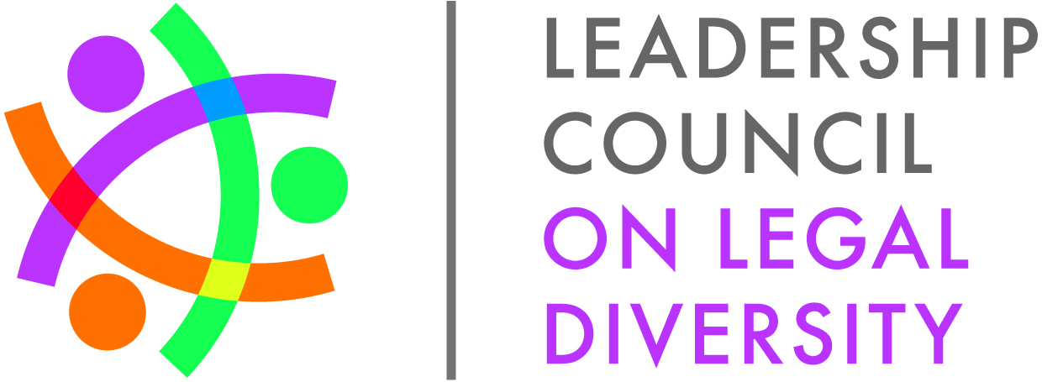**Diversity Director’s Conference Call**

**April 9, 2015**

**3:00-4:00pm EDT**

**Agenda**

**Call In: 877-294-8214**

**Access Code: 5075876**

1. Welcome
2. Program Updates
   1. 2015 Fellows class (Program Contact: Stephanie Uzel, [suzel@lcldnet.com](mailto:suzel@lcldnet.com))
      1. Feedback from March Fellows meeting

* Added an element of introductory coaching skills to enhance the accountability partner work the Fellows do.
* Gave good insight on different generations and how people work together.
* Did not hear a lot about the tenets of LCLD and how we are supposed to work together with the Fellows. Make sure to distinguish it from conferences.
* The Fellows liked being seated with other Fellows in their geographical region.
  + 1. Learning Experiences for 2015 Program
* Department of Justice is April 27, 2015 in Washington, DC
* Starbucks is June 4 & 5, 2015 in Seattle, WA
* 3M is October 27, 2015 in St. Paul, MN
* SEC is November 5, 2015 in Washington, DC
  + 1. Leadership Lunches – please let us know if your General Counsel or Managing Partner is interested in hosting (currently scheduling June, October, November, December)
  1. Fellows Alumni
     1. 2015 Fellows Alumni Conference, June 11-14 in New Orleans, LA (Program Contact: Courtney Nolde, [cnolde@lcldnet.com](mailto:cnolde@lcldnet.com))
        1. Sponsorship opportunities available
        2. Kenji Yoshino keynote speaker; CLE credit applied for
     2. Alumni Executive Council
* The EAC is working to better align their strategic goals with their committees and work groups after a strategy session at Deloitte University.
* Opportunities for leadership in the alumni community will open this summer
  1. 2015 LCLD Success in Law School Mentoring Program (Program Contact: Louise Bald, [lbald@lcldnet.com](mailto:lbald@lcldnet.com))
     1. City Lead – call for volunteers; City Lead training April 30 in Atlanta, GA
     2. Mentor registration for 2015-2016 program begins June 1
     3. Mentor program surveys for 2014-2015 program due June 1
  2. 2015 1L Scholars Program (Program Contact: Louise Bald, [lbald@lcldnet.com](mailto:lbald@lcldnet.com))
     1. 2015 Scholars Summit, May 28-30, 2015 in Dallas, TX
        1. Register your Scholars online by May 1 (if you’re working in partnership with another LCLD organization, please note both). Register at [www.lcldnet.org](http://www.lcldnet.org) and click the banner.
        2. Hotel reservations by May 18

1. Annual Meeting Save the Date: September 28-29 in Chicago. Registration opens in May.

* There is a session for Diversity Professionals again this year. If you have thoughts or suggestions for this session, please email Lori Lorenzo [llorenzo@lcldnet.com](mailto:llorenzo@lcldnet.com)

1. Communications
   1. Have a good diversity story, award, initiative? Had a great experience with one of LCLD’s programs? Share it with us, email Caitlin at [cpuffenberger@lcldnet.com](mailto:cpuffenberger@lcldnet.com).
   2. Put LCLD on your organization’s diversity page, email Caitlin at [cpuffenberger@lcldnet.com](mailto:cpuffenberger@lcldnet.com) for more information.
   3. Social media – tag or follow us and we’ll return the favor
      1. Twitter: <https://twitter.com/LCLD_rgrey>; <https://twitter.com/LoriLCLD>
      2. Facebook: <https://www.facebook.com/TheLCLD>
      3. LinkedIn: <https://www.linkedin.com/groups?home=&gid=4198149&trk=my_groups-tile-grp>
2. Questions/Comments/Suggestions